1. What are the most common incident groups and categories?
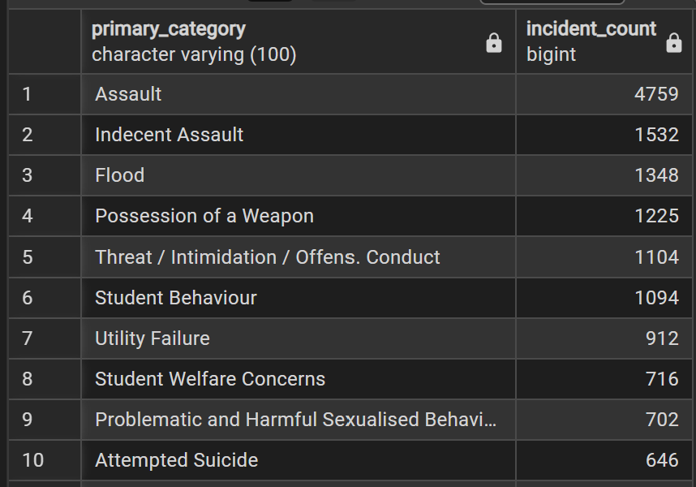
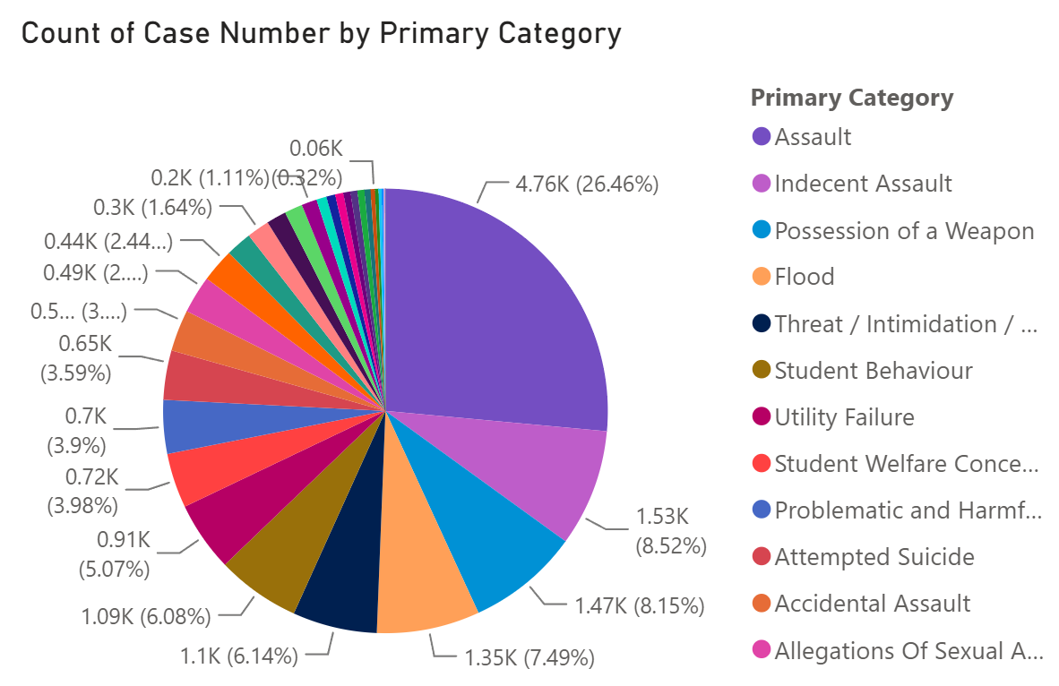

2. How has incident volume changed over time?
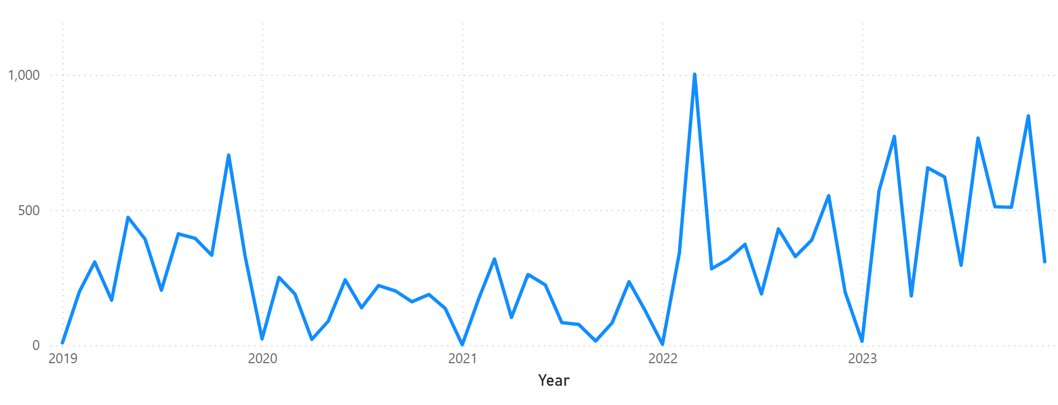
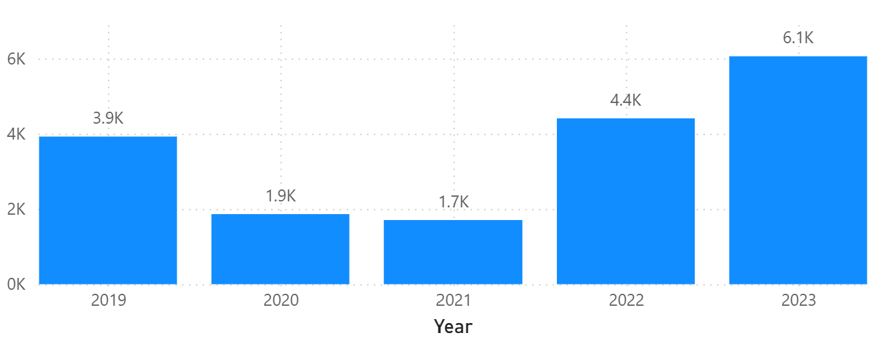
Upwards trend. Incidents dipped in 2020/2021 because of COVID, but sharply rose afterwards, exceeding pre-COVID (2019) years.

3. How does incident volume vary by school term?
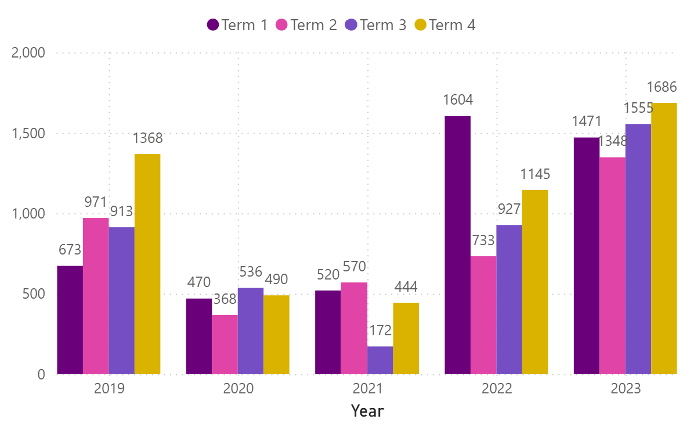
No noticeable pattern. The most recent years (2022, 2023) suggest a pattern of increasing incidents in Term 1 and 4.
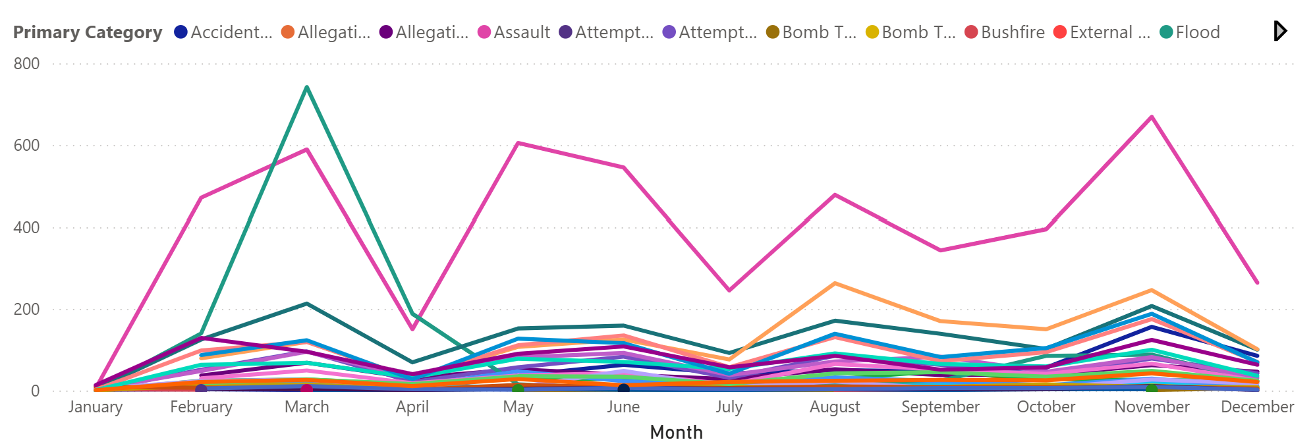
Incidents consistently peak during March, May, August, November.

4. Where do incidents most commonly occur?
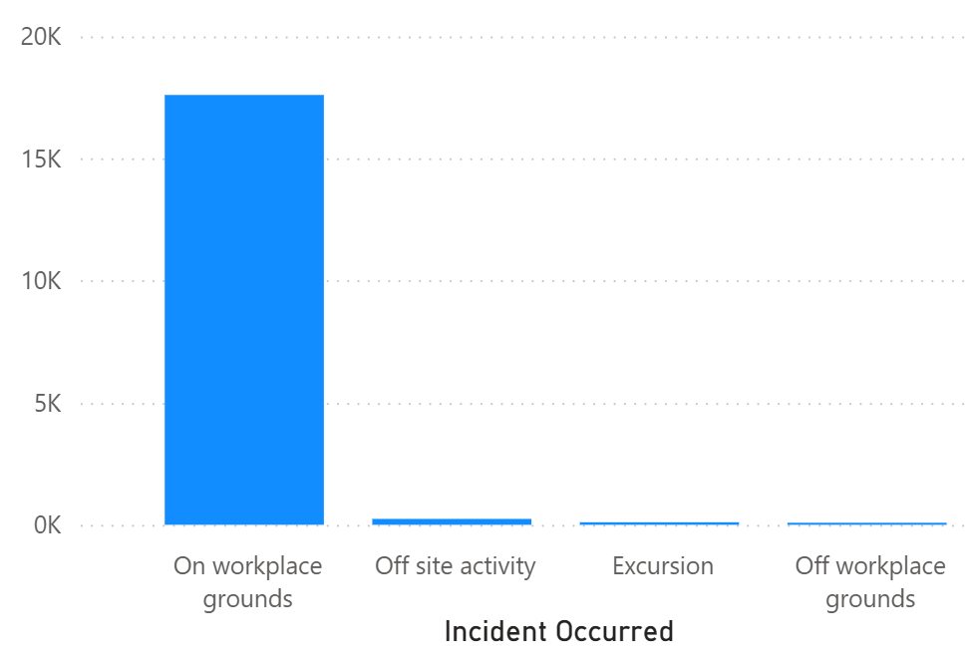
Most incidents occur at school. However, most incidents outside of school won’t be reported, so the number of incidents in ‘Off workplace grounds’ is incomplete.

5. How does incident type vary by location/context?
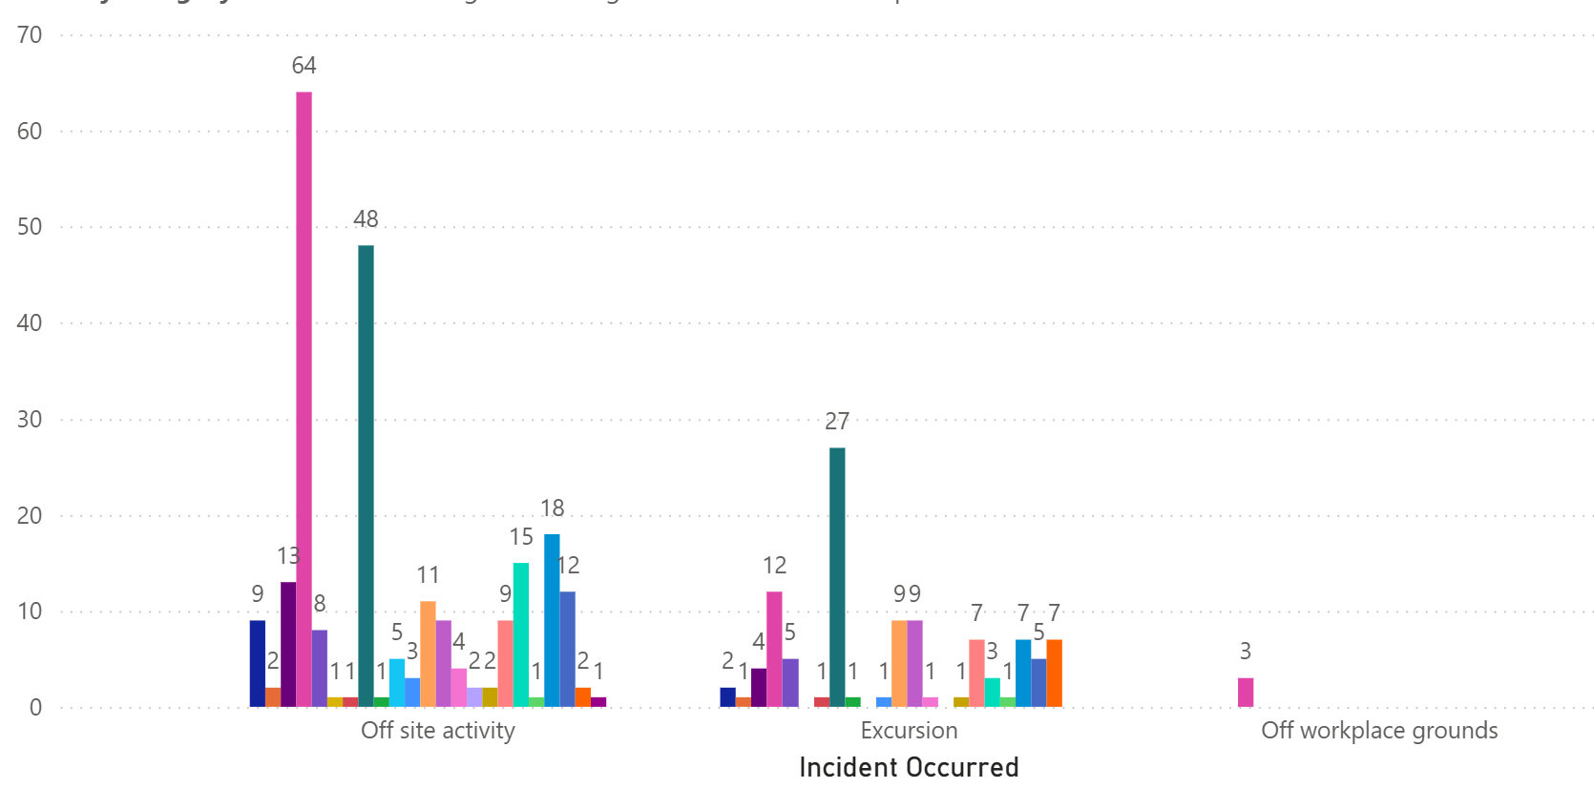
Assault (PINK) and Indecent Assault (DARK GREEN) are the most common incident types. However, during excursions, Indecent Assault is more common.

6. How does the incident profile differ between operational directorates?
Rural North and Regional South are the most vulnerable to floods.
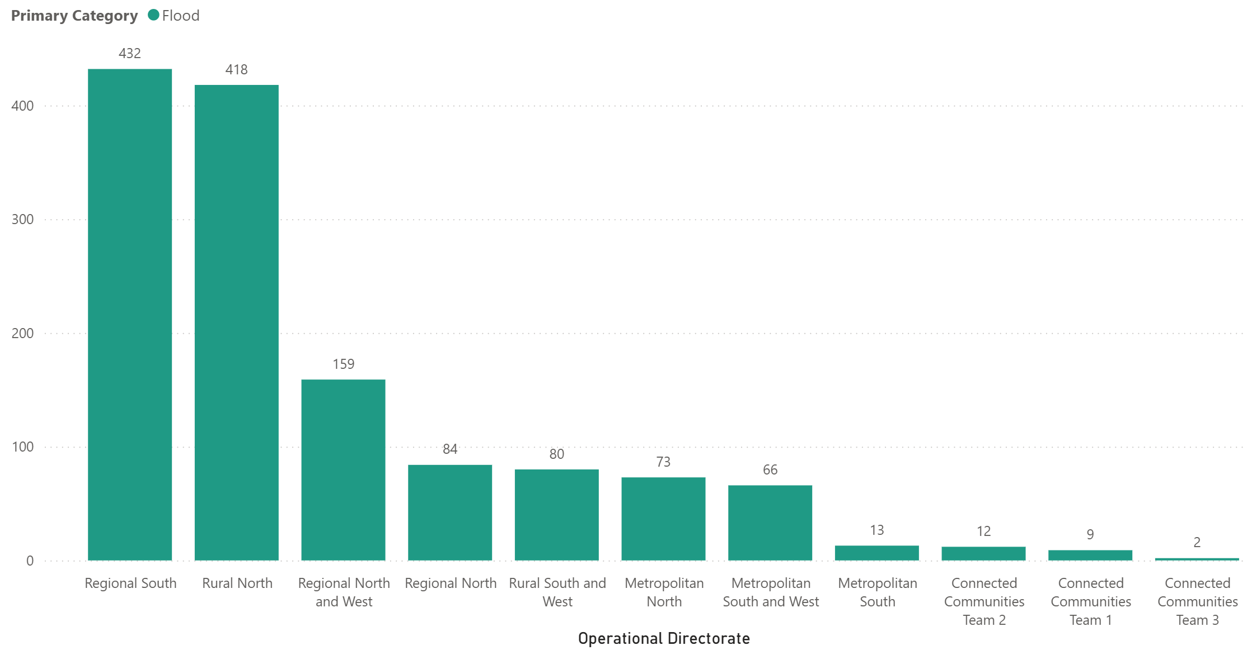
Drug use is evenly distributed.
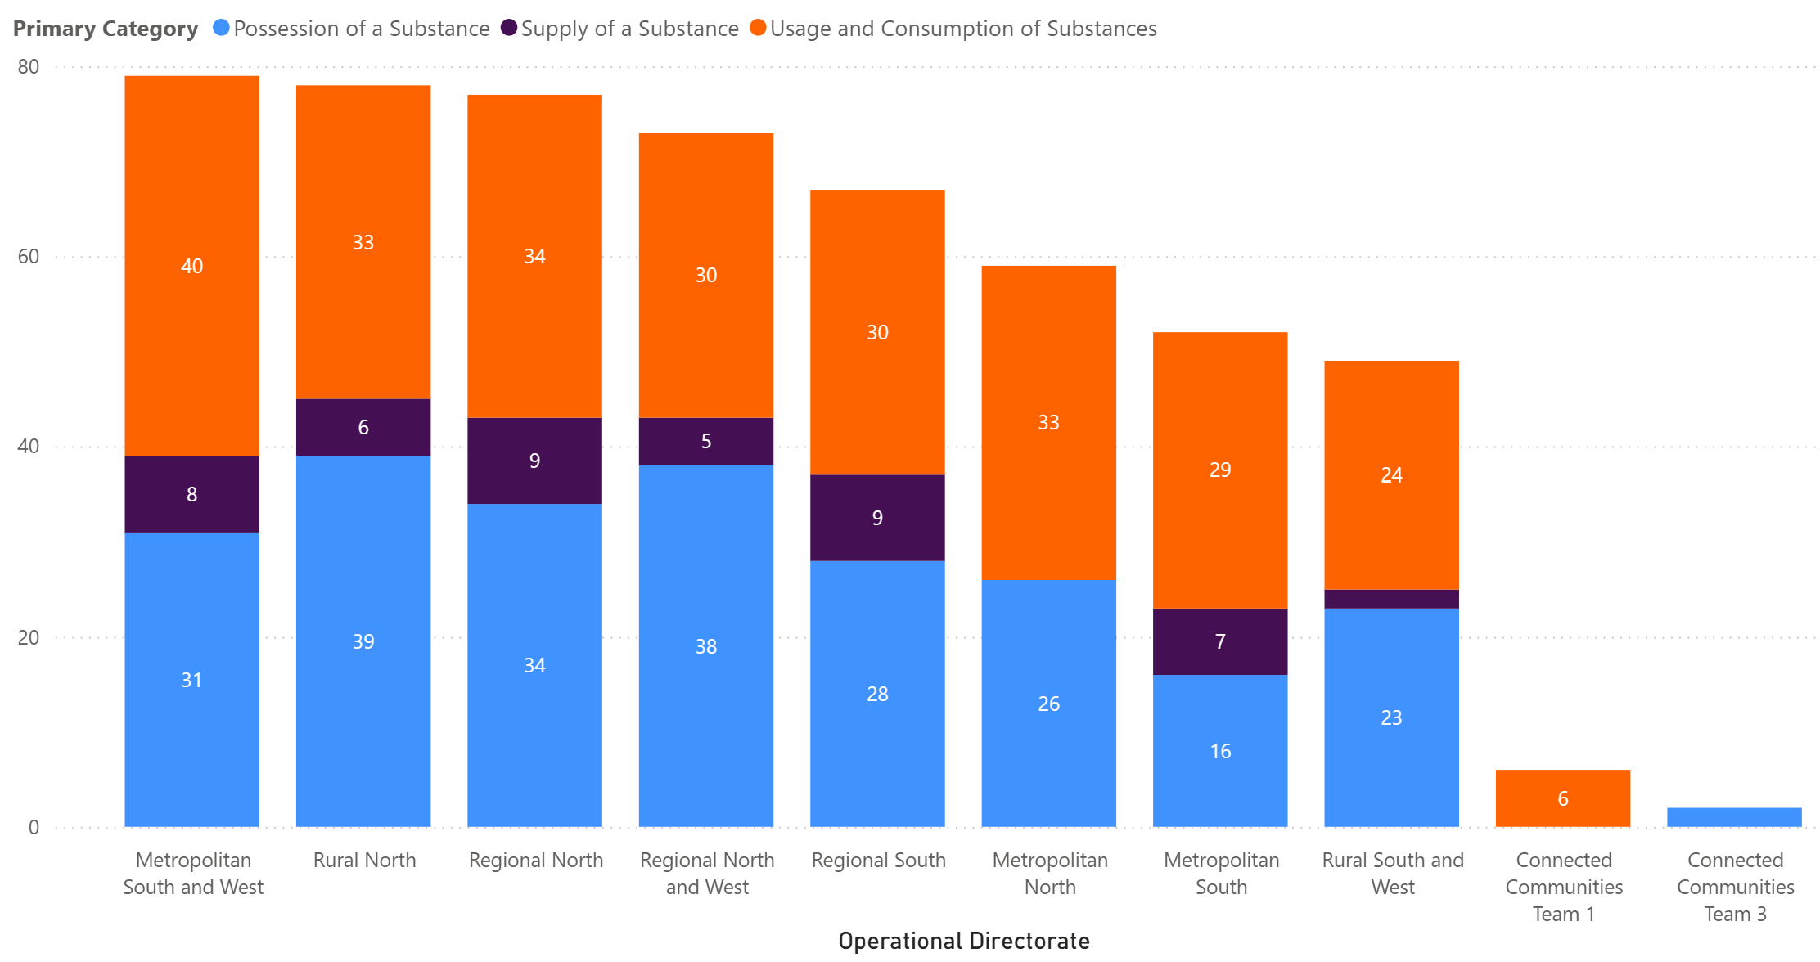
Regional North takes the lead in suicidality.
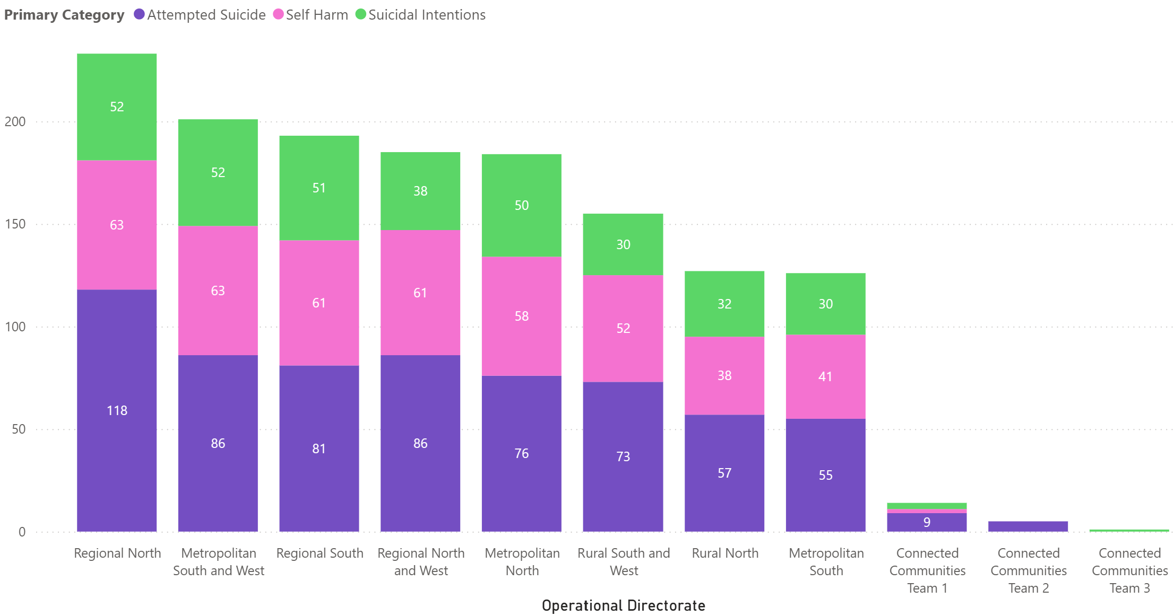
Metropolitan South and West has the highest rates of sexual incidents.
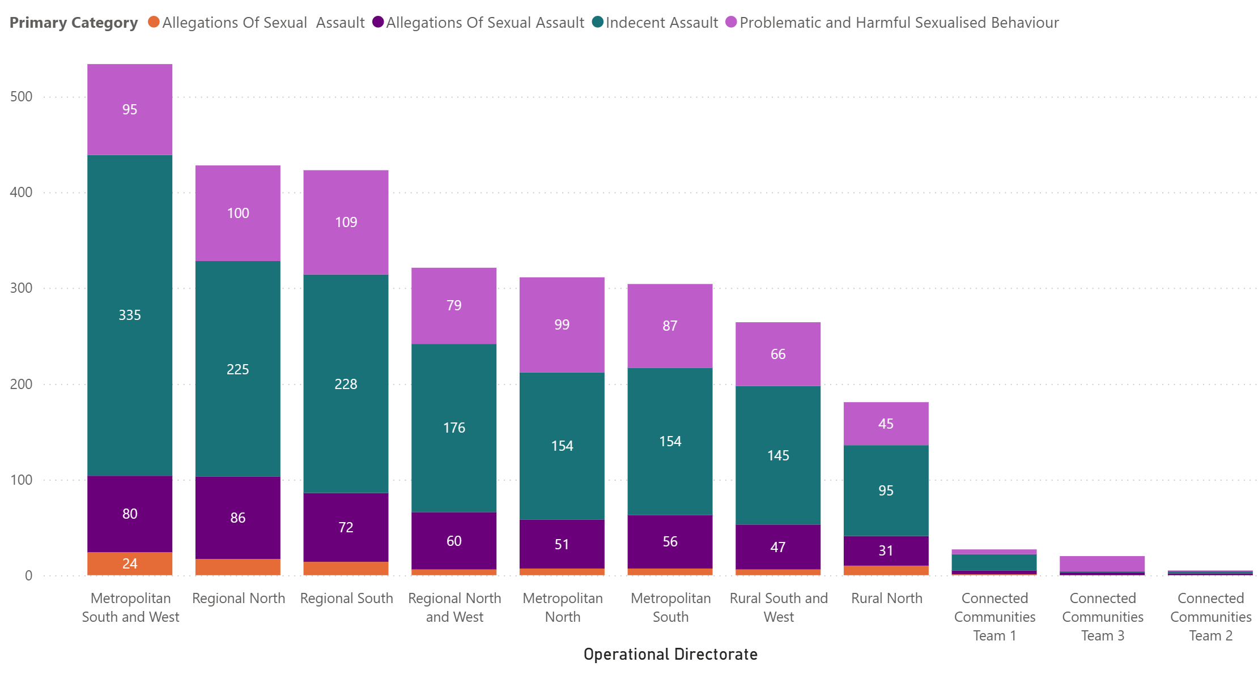
Metropolitan South and West take the lead for the most serious incidents where police needed to be called.
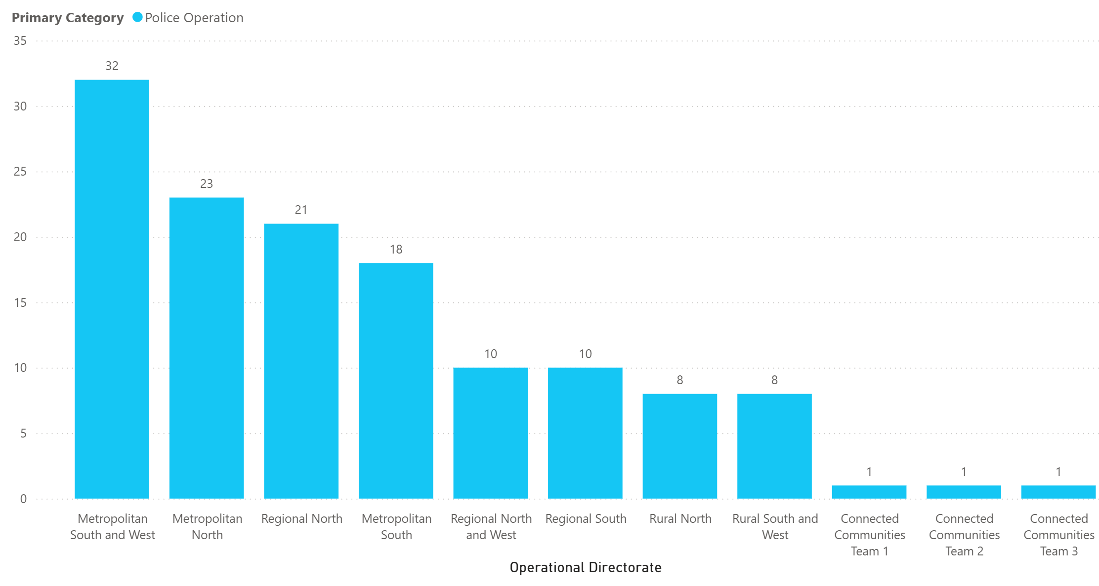
7. Has the composition of incidents changed over time?
Assault has consistently been the highest category (see question 3 line graph).
Outlier - over 1000 flood incidents in 2022.
Composition remains largely the same, with higher incident count over time.z
8. What are the most important patterns or anomalies revealed by the data?
- Assault and indecent/sexual assault is more common during off site activities and excursions, so teachers need to increase vigilance and take more measures.
- More incidents occurring.

